MEMORANDUM
TO:
FROM:
DATE:
SUBJECT: Running a Laptop without a Battery
Introduction
On August 3rd, 2020, I decided to inspect using a laptop without a battery to determine the safety of the device and the user if the battery is the default. The inspection describes the vital background information geared to the investigation, the security, data obtained from the review, the facts, the finding's summary, and the recommendations for future use. Since I was not leaving the house made me buy the idea of not replacing a laptop battery incorporating the standards of a capable laptop.
Background
The importance of the inspection evident since there is a significant laptop default, which may take a substantial amount of time to be replaced or to acquire a new one. I decided to remove the battery from the laptop and continue to use it on AC power. I did not intend to leave the house to determine its effectiveness and safety when running without a battery. It would be determined by the efficiency of the laptop running without a battery but somewhat connected to the AC power.
The inspection was based on a checklist addressing the following:
- Can a laptop effectively function without a battery?
- Is the laptop performance affected or harmed in any way?
- Is running a computer without a battery safe for the device and myself also?
- Are there any aspects required to be taken into account when using a laptop without a battery?
I went ahead with the inspection, having removed the battery from the laptop. My main objective was to determine how it would behave as compared to when running when the battery is still on. I considered its effectiveness in the performance, safety, and the various aspects that need to be taken into account when running a computer without a battery direct from the AC power.
FACTS
The inspection was successful. Generally, the computer's performance was not affected in any way as it continued to function just as before. There was no genuine reason why a computer may fail to work as usual without the battery in it has considered a few aspects. First, I ensured that I used the original power adapter that initially came with the laptop. One of the critical elements to note here is that variations in power can cause features on the motherboard to fail, and this can be prevented by the battery, which will act the same way a UPS would.
When considering power, it is not advisable to use a laptop without a battery where high-intensity electrical loads are experienced. It is a precaution to ensure that the computer does not suffer any damage in case of a high load. I also found that the power cord should never be removed from the laptop when working, as this could lead to injuries to its components. Another important aspect is that the battery contacts should never be touched when plugged in. To prevent the adapter from falling off, I used a rubber band. Finally, I ensured that I only removed the battery when the laptop was unplugged and turned off.
OUTCOME
Once I removed the battery from the laptop and considered the above-discussed aspects, the inspection was successful. The computer functioned effectively and as usual, and no component was endangered to risk. My safety as well as guaranteed in the investigation as there was no high-intensity electrical load. To safeguard my battery before removing it, I ensured that it was charged to around forty percent; otherwise, I would do a charge-discharge cycle regularly to prolong the battery life. The inspection was successful from the fact that I took into consideration some of the critical aspects.



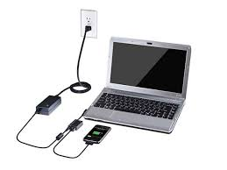


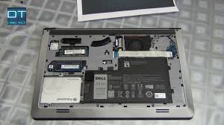

SOURCES.
https://www.groovypost.com/wp-content/uploads/2013/09/laptop-battery-troubleshooting-repair-computer-featured.jpg
Williams, A., & Yakimenko, O. (2018, April). Persistent mobile aerial surveillance platform using intelligent battery health management and drone swapping. In 2018 fourth International Conference on Control, Automation and Robotics (ICCAR) (pp. 237-246). IEEE.

